|  |
| --- |
| Microsoft SharePoint 2013 - Hands-on Lab |
| SharePoint 2013 App Model – Introduction |
| Verified Against Build #15.0.4420.1017 |

|  |
| --- |
| Microsoft  Version 1.0  August 14, 2012 |

Information in this document, including URL and other Internet Web site references, is subject to change without notice. Unless otherwise noted, the example companies, organizations, products, domain names, e-mail addresses, logos, people, places, and events depicted herein are fictitious, and no association with any real company, organization, product, domain name, e-mail address, logo, person, place, or event is intended or should be inferred. Complying with all applicable copyright laws is the responsibility of the user. Without limiting the rights under copyright, no part of this document may be reproduced, stored in or introduced into a retrieval system, or transmitted in any form or by any means (electronic, mechanical, photocopying, recording, or otherwise), or for any purpose, without the express written permission of Microsoft Corporation.

The names of manufacturers, products, or URLs are provided for informational purposes only and Microsoft makes no representations and warranties, either expressed, implied, or statutory, regarding these manufacturers or the use of the products with any Microsoft technologies. The inclusion of a manufacturer or product does not imply endorsement of Microsoft of the manufacturer or product. Links are provided to third party sites. Such sites are not under the control of Microsoft and Microsoft is not responsible for the contents of any linked site or any link contained in a linked site, or any changes or updates to such sites. Microsoft is not responsible for webcasting or any other form of transmission received from any linked site. Microsoft is providing these links to you only as a convenience, and the inclusion of any link does not imply endorsement of Microsoft of the site or the products contained therein.

Microsoft may have patents, patent applications, trademarks, copyrights, or other intellectual property rights covering subject matter in this document. Except as expressly provided in any written license agreement from Microsoft, the furnishing of this document does not give you any license to these patents, trademarks, copyrights, or other intellectual property.

Copyright © 2012 Microsoft Corporation. All rights reserved.

Microsoft and SharePoint are either registered trademarks or trademarks of Microsoft Corporation in the United States and/or other countries.

The names of actual companies and products mentioned herein may be the trademarks of their respective owners.

# Technical Background

This lab requires you first run a script that creates a dedicated SharePoint site collection that you will use throughout all exercises in this lab. By working in an isolated site collection, you can rest assured that your changes will not affect other sites in the environment.

## Create Lab SharePoint Site Collection

In the files provided with the hands on lab, run the batch file called SetupModule.bat by double clicking it. This file will execute a PowerShell script that will create a new site collection at <http://intranet.contoso.com/sites/IntroSpApps>.

|  |
| --- |
| Description: C:\Users\vesaj\Pictures\DVD_ART36\Artwork_Imagery\Icons - Illustrations\_ SUPER VISTA STYLE\yield sign red white exclamation point.png **Important** |
| *It is important you run this batch file to create the site collection before working through any of the exercises as the exercises contain instructions for working with this specific site collection at the specific URL created by the script.* |

The script will first check to see if there is already a site collection at the specified address. If there is it will delete the site collection before creating it. Therefore if you run into problems with the lab, feel free to rerun the batch file to reset the environment and restart the exercise.

# Introduction

## Estimated time to complete this lab

30 minutes

## Objectives

After completing this lab, you will be able to:

* Understand how apps are displayed and used within SharePoint sites
* Understand how the SharePoint app isolation works

## Overview of Lab

SharePoint Apps can be centered on SharePoint artifacts, cloud resources, or both. In this lab, you will explore the new SharePoint 2013 user interface centered on the new application model. In addition you will explore the differences between an application hosted in SharePoint vs. ones hosted in the cloud with Windows Azure and an on-premise application.

## Computers in this lab

This lab uses virtual machines as described in the following table. Before you begin the lab, you must start the virtual machines and then log on to the computers.

|  |  |
| --- | --- |
| **Virtual Machine** | **Role** |
| {Supplied by Instructor} | Domain Controller |
| {Supplied by Instructor} | Actual SharePoint environment with Office client and other required software. |

All user accounts in this lab use the password {Supplied by Instructor}.

## Lab Setup Script

In the files provided with the hands on lab, run the batch file called **SetupModule.bat** by double clicking it. This file will execute a PowerShell script that will create a new site collection at [http://intranet.contoso.com/sites/IntroSpApps](http://intranet.contoso.com/sites/IntroSpApps%20) .

# Exercise 1: Hello Apps!

In this exercise you will explore the new Apps page to get familiar with the new app presentation experience in SharePoint 2013.

## Task 1 – Explore the new App-Centric SharePoint User Experience

This task will have you creating a copy of the student directory to the SQL server so you later restore a database from this location.

* Begin this task logged on to **SP** as **CONTOSO\Administrator**

1. Open **Internet Explorer** and navigate to the [http://intranet.contoso.com](http://wave15-sp)/sites/IntroSpApps site.
2. The updated user interface of a SharePoint team site favors the app-centric approach to sites. Previous version of SharePoint included a link View All Site Content in the Quick Launch navigation. This link has been changed to Site Contents. Click the **Site Contents** link at the bottom of the Quick Launch navigation on the left-hand side of the page to see a list of the apps installed in this site:

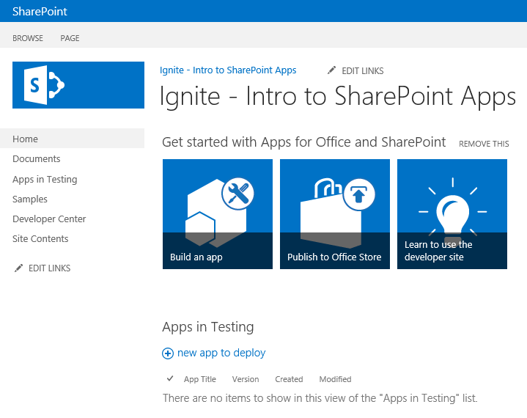

1. The **Lists, Libraries, and other Apps** page contain a list of all the apps that have been installed in the SharePoint site. Existing lists and document libraries are now presented as apps. Lists and libraries are still treated as such, they are just displayed as apps for a consistency of presentation.
2. Click the **Documents** app to navigate to the Documents library: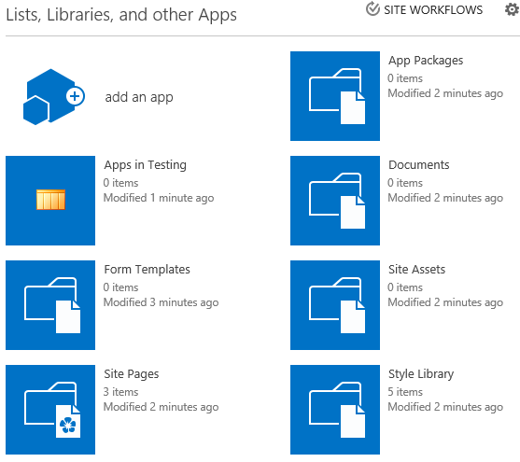

## Task 2 – Create a new SharePoint Contact List as an App

In this task you will create a SharePoint contact list as an app.

* Begin this task logged on to **SP** as **CONTOSO\Administrator**

1. Open **Internet Explorer** and navigate to the [http://intranet.contoso.com](http://wave15-sp)/sites/IntroSpApps site.
2. Navigate to the **Lists, Libraries, and other Apps** page by clicking the **Site Contents** link in the bottom of the Quick Launch navigation.
3. Create / Install a new instance of an app by clicking the Add an App at the top of the **Lists, Libraries, and other Apps** page:

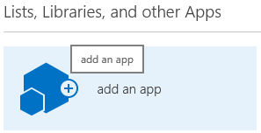

1. The **Add an App** page will present you with the ability add an app to your site using either the list of installed apps (the main area of the page) or by acquiring an app from the public Marketplace or Corporate Catalog (using links in the left-hand navigation):

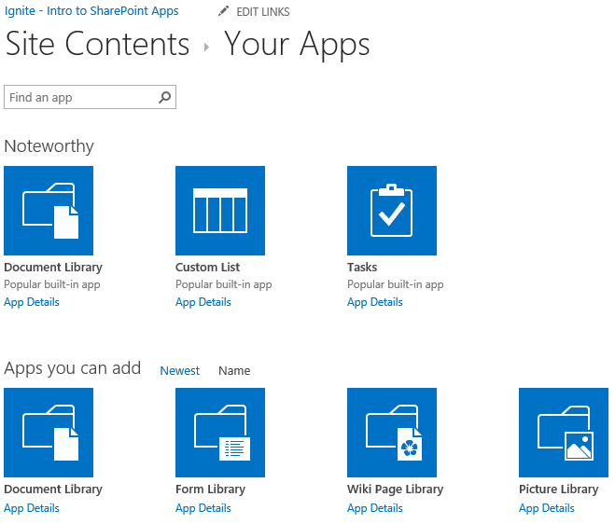

1. Create a new instance of an app by clicking the **Announcements** app.
2. On the Adding Announcements dialog, give the name of the app a unique name. Since this is the only announcements list on the site, set the **Name** to **Announcements** and click **Create**.
3. Nice the app has been created and is displayed on the **Lists, Libraries, and other Apps** page:

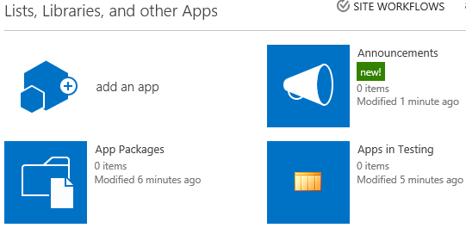

# Exercise 2: Deploy and Create an Instance of a Custom SharePoint App

In this exercise you will deploy a new SharePoint App created by a developer to a SharePoint site collection. After deploying the app to a site collection, you will then create a new instance of the app and explore the app isolation implemented with custom URLs.

## Task 1: Create a New Subsite in a SharePoint site

In this task you will create a new subsite in an existing SharePoint site.

* Begin this task logged on to **SP** as **CONTOSO\Administrator**.

1. Open **Internet Explorer** and navigate to the [http://intranet.contoso.com](http://wave15-sp)/sites/IntroSpApps site.
2. Go to the **Lists, Libraries, and other Apps** page by clicking the **Site Contents** link in the Quick Launch navigation.
3. Scroll to the bottom of the Apps page and click the **new subsite** link in the **Subsites** section of the page.
4. Use the following to create the new SharePoint site followed by clicking **Create** at the bottom of the page:

* **Title:** Sample Team Site
* **URL Name:** <http://intranet.contoso.com/sites/IntroSpApps/sampleteam01>
* **Select a Template:** Team Site

1. Verify the subsite is showing in the browser:
   * Navigate back to [http://intranet.contoso.com](http://wave15-sp)/sites/IntroSpApps in Internet Explorer.
   * Go to the **Lists, Libraries, and other Apps** page by clicking the **Site Contents** link in the Quick Launch navigation.
   * Scroll to the bottom of the **Lists, Libraries, and other Apps** page and notice the site is listed as the only site under the Sites section:

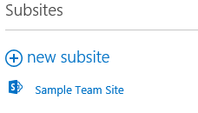

1. Verify the subsite is showing in Windows PowerShell:
   * Open a Microsoft SharePoint 2013 Shell (**Start ⮚ All Programs ⮚ Microsoft SharePoint 2013 Products ⮚ SharePoint 2013 Management Shell**).
   * Run the following PowerShell scripts to see a list of all the subsites in the current site:

PS C:\> $site = Get-SPWeb [http://intranet.contoso.com](http://wave15-sp)/sites/IntroSpApps

PS C:\> $site.Webs | Format-List Url

* + Notice only one site is listed, the site that was just created.

## Task 2: Install a custom developed SharePoint app in a site collection

Install a SharePoint app that was previously created into the SharePoint site.

* Begin this task logged on to **SP** as **CONTOSO\Administrator**.

1. Open Visual Studio 2012 (**Start ⮚ All Programs ⮚ Microsoft Visual Studio 2012 ⮚ Visual Studio 2012**).
2. In Visual Studio, open an existing solution by clicking **File ⮚ Open ⮚ Project/Solution**. When prompted for a location, open the **..\SimpleSharePointHostedApp\SimpleSharePointHostedApp.sln** solution found in the files corresponding to this lab.
3. Deploy the app to the SharePoint site by right-clicking the project name in the **Solution Explorer** tool window in Visual Studio 2012 and select **Deploy**:

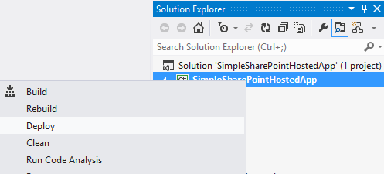

1. Once Visual Studio deploys the app, verify it is installed in the target SharePoint site:
   * Navigate using Internet Explorer to [http://intranet.contoso.com](http://wave15-sp)/sites/IntroSpApps.
   * Click the **Site Contents** link in the Quick Launch navigation.
   * You should now see an app with the name of **Simple SharePoint Hosted App** in the list of apps:

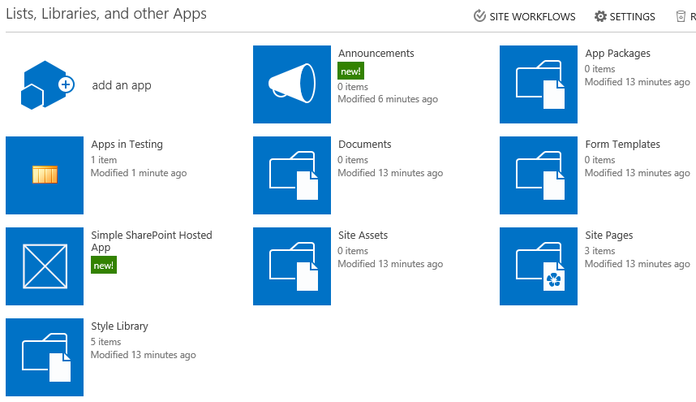

## Task 3: Examine the SharePoint App isolation using unique domains

In this task you will explore the custom AppWeb that is created and the URLs associated with it and the hosting site from the app installed in the previous task.

* Begin this task logged on to **SP** as **CONTOSO\Administrator**.

1. Open Internet Explorer and navigate to [http://intranet.contoso.com](http://wave15-sp)/sites/IntroSpApps.
2. Click the **Site Contents** link in the **Quick Launch** navigation.
3. On the Apps page, click the **Simple SharePoint Hosted App**.
4. Notice the URL of the app changes… specifically the domain name part of the URL is very different from [http://intranet.contoso.com](http://wave15-sp)/sites/IntroSpApps, the URL of the hosting site.
5. Verify this new AppWeb that hosts the app does not show up in SharePoint:
   * Go back to the [http://intranet.contoso.com](http://wave15-sp)/sites/IntroSpApps site.
   * Click the **Site Contents** link in the **Quick Launch** navigation.
   * Scroll to the bottom of the page and notice the hosting AppWeb is not listed in the list of other SharePoint subsites.
6. View all the sub sites in the current SharePoint site using PowerShell:
   * Open a Microsoft SharePoint 2013 Management Shell (**Start ⮚ All Programs ⮚ Microsoft SharePoint 2013 Products ⮚ SharePoint 2013 Management Shell**).
   * Run the following PowerShell scripts to see a list of all the subsites in the current site:

PS C:\> $site = Get-SPWeb <http://intranet.contoso.com>/sites/IntroSpApps

PS C:\> $site.Webs | Format-List Url

* + Notice two sites are now listed, one with the URL starting with [http://intranet.contoso.com](http://wave15-sp)/sites/IntroSpApps (the content site) and one with a very different URL.
  + Because the AppWeb is a subsite in the current site, one would think you could simply change the domain name in the URL and be able to access the site. Try this by copying the URL from the AppWeb but replacing the domain with [http://intranet.contoso.com](http://wave15-sp)/sites/IntroSpApps in the browser.
  + Notice SharePoint redirects you to the custom URL for the app. The redirection ensures that the app is never accessible on the same domain as the hosting SharePoint site. This technique blocks an app from doing cross site scripting and connecting to the hosting SharePoint site because they are both in the same domain. By putting the app in a unique domain, it mitigates cross site scripting concerns.
* This is the end of the lab

# Lab Summary

In this you performed following tasks.

* + - * Explored the new SharePoint app-centric user experience
      * Deployed a custom SharePoint app created by a developer
      * Created an instance of a deployed SharePoint App
      * Explored the app isolation implementation with custom URLs